**Journey Through The Bible**

**DORCAS**

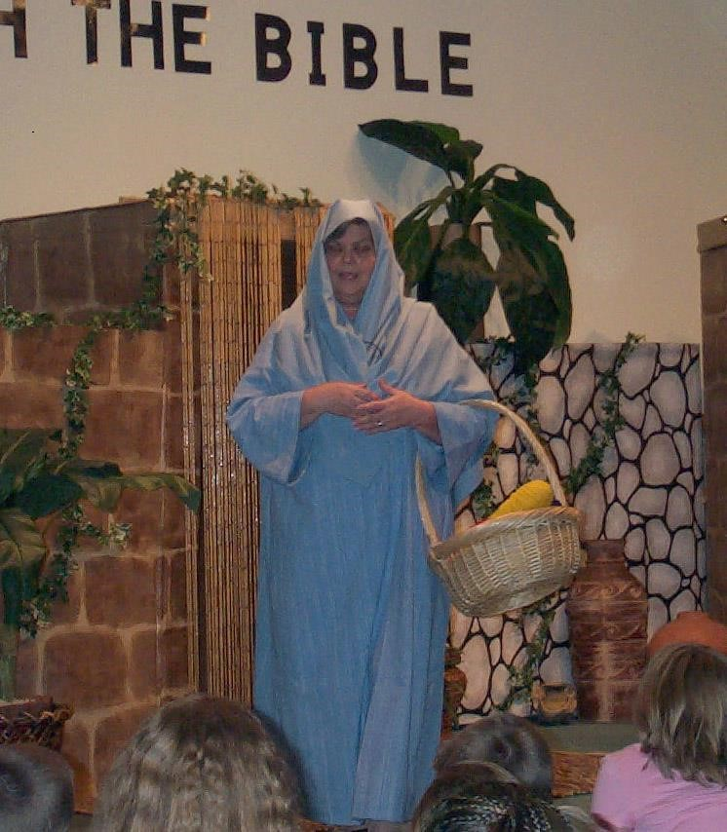

I am a disciple of Christ named Tabitha, but I am called Dorcas. I live in Jappa. I like to do good works and charitable deeds. One day, I became sick and died. The women washed me and laid me in an up stairs room.

Peter was close by in Lydda and when the disciples heard that he was there they sent for him. Peter came and saw my friends crying. They showed him the clothes I had made.

Peter sent the women out of the room, and he knelt beside my body and prayed. He said to me “Tabitha, get up.” I opened my eyes, saw Peter, and sat up. Peter took my hand. He lifted me up, and he presented me alive to all the good people. I could hear everyone saying, “Look, he raised her from the dead!” and “I can’t believe what I’m seeing.” “This is a real miracle!”

Everybody found out about this, and many people believed in Jesus because of my being raised from the dead. Peter stayed in Joppa with his friend, Simon, the tanner.

This story is from the book of Acts. (Prepare a few questions to ask the boys and girls about your character.)

**Scripture reading**: Acts 9:36-42

**Memory Verse:** Psalms 100:2

Serve the LORD with gladness;

Come before His presence with singing.